LOAD BALANCER
- Configure Classic Load balancer.

🛠️ Steps to Create a Classic Load Balancer
- Open the EC2 Console
  - Navigate to EC2 → Load Balancers → Create Load Balancer.
  - Select Classic Load Balancer.
- Define Basic Settings
  - Name: Choose a unique name.
  - Scheme: Select Internet-facing (for public traffic) or Internal (for private VPC traffic).
  - Listeners: Configure front-end and back-end protocols/ports.
    - Example: HTTP (port 80) → HTTP (port 80).
    - You can add multiple listeners (e.g., HTTPS).
- Assign Security Groups
  - Choose or create a security group that allows inbound traffic on the listener ports (e.g., 80/443 for web, 22 for SSH if needed).
- Configure Health Checks
  - Define how the CLB checks instance health.
  - Example:
    - Protocol: HTTP
    - Ping Path: /
    - Port: 80
    - Healthy threshold: 2
    - Unhealthy threshold: 2
    - Timeout: 5 seconds
    - Interval: 30 seconds
- Add EC2 Instances
  - Select the running EC2 instances you want behind the load balancer.
  - Ensure they are in the same VPC and availability zones.
- Configure Additional Settings (Optional)
  - Cross-Zone Load Balancing: Distributes traffic evenly across AZs.
  - Connection Draining: Allows existing connections to complete before deregistering instances.
- Review and Create
  - Double-check all settings.
  - Click Create to launch the CLB.

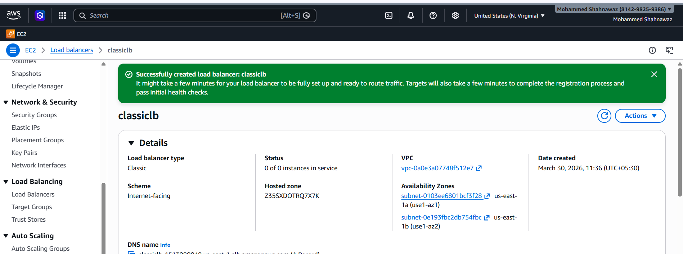
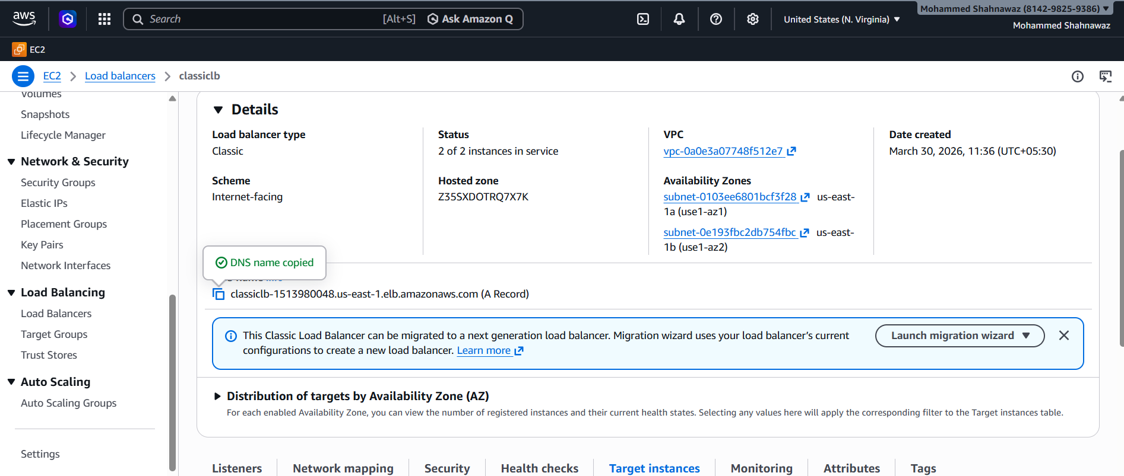
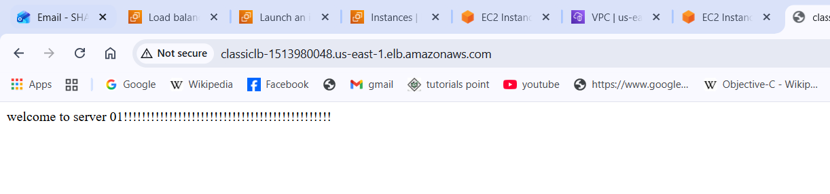
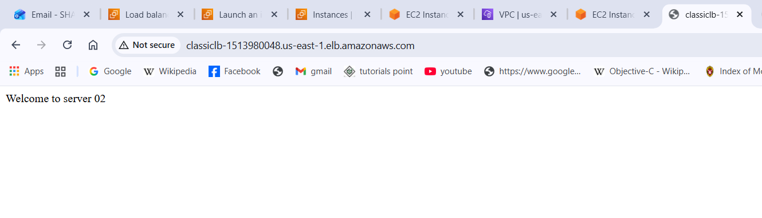

- Configure Application Load balancer.

Steps to Configure an Application Load Balancer
- Prerequisites
  - Ensure you have a VPC with at least two subnets in different Availability Zones.
  - Deploy at least one EC2 instance or target in each AZ.
  - Decide if you need IPv4 only or dual-stack (IPv4 + IPv6).
- Create the ALB
  - Go to EC2 → Load Balancers → Create Load Balancer → Application Load Balancer.
  - Name: Choose a unique name.
  - Scheme: Select Internet-facing (for public apps) or Internal (for private apps).
  - IP Address Type: IPv4 or dual-stack.
- Configure Network Settings
  - Select the VPC.
  - Choose subnets in at least two Availability Zones for high availability.
- Assign Security Groups
  - Attach a security group that allows inbound traffic on listener ports (e.g., 80 for HTTP, 443 for HTTPS).
  - Outbound rules should allow traffic to backend targets.
- Set Up Listeners
  - Add listeners for HTTP (80) or HTTPS (443).
  - For HTTPS, upload an SSL/TLS certificate from ACM or IAM.
- Create Target Groups
  - Define a target group (EC2 instances, IP addresses, or Lambda functions).
  - Choose protocol (HTTP/HTTPS).
  - Configure health checks (path, port, thresholds).
- Register Targets
  - Add EC2 instances or IPs to the target group.
  - Ensure instances are running and security groups allow traffic from the ALB.
- Configure Routing Rules
  - Add rules for path-based or host-based routing.
  - Example:
    - /api/* → API target group
    - /images/* → Image server target group
- Review and Create
  - Double-check all settings.
  - Click Create Load Balancer.
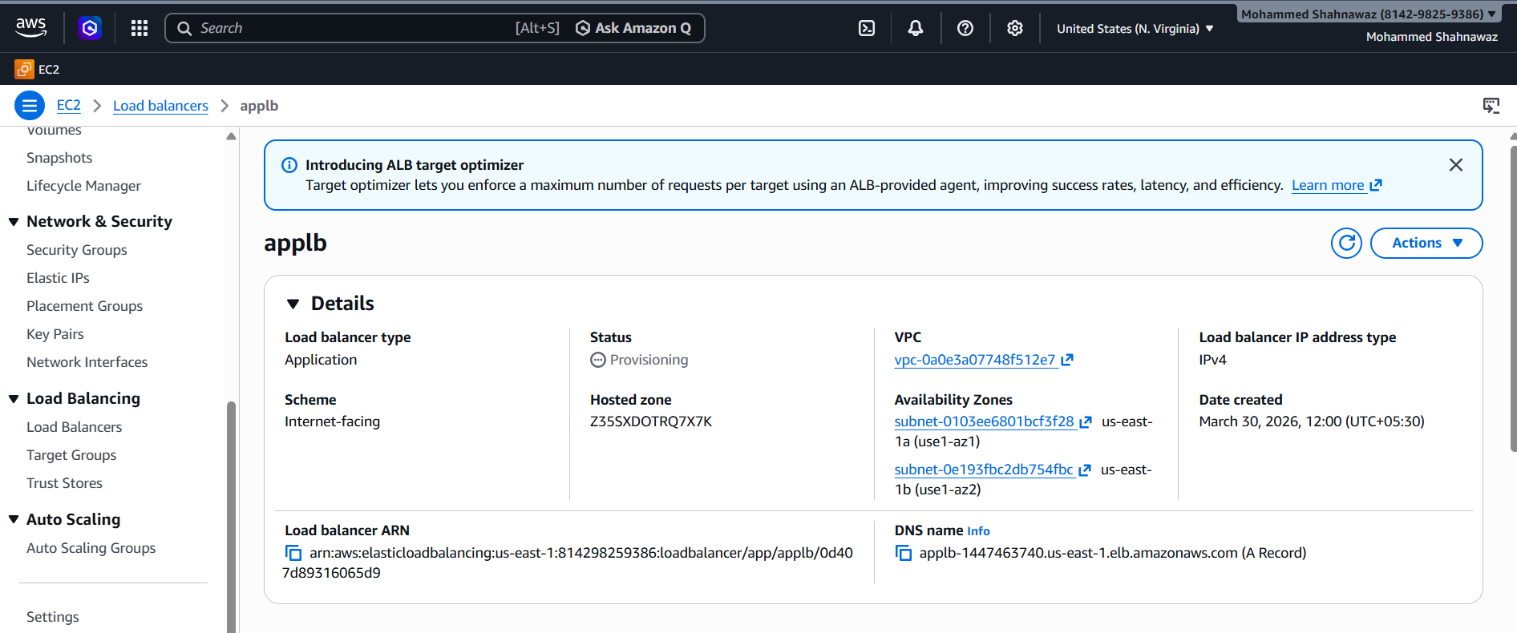
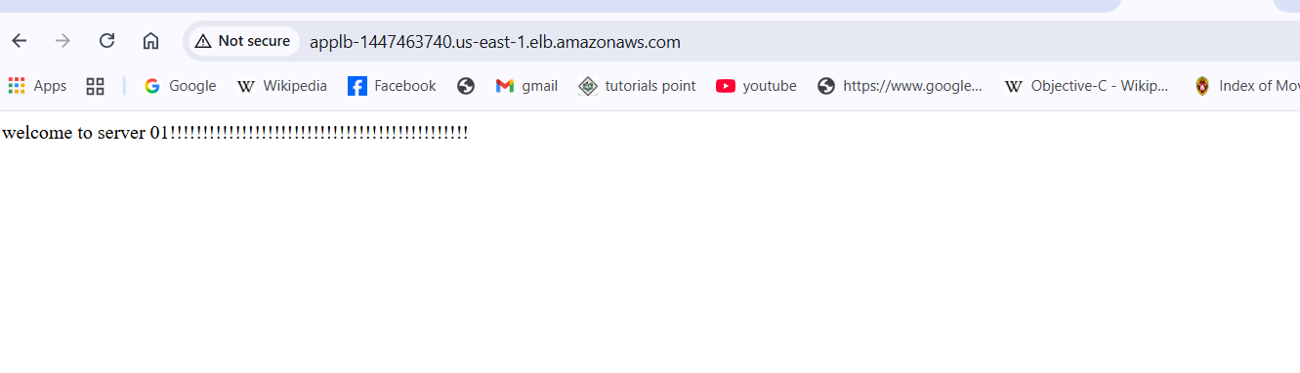
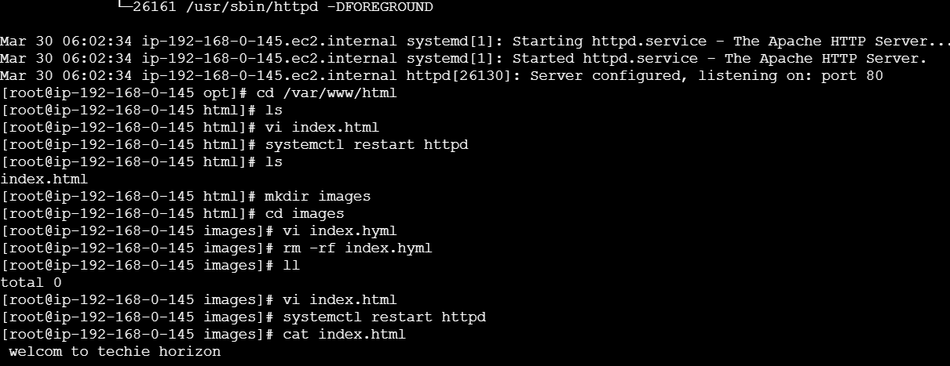
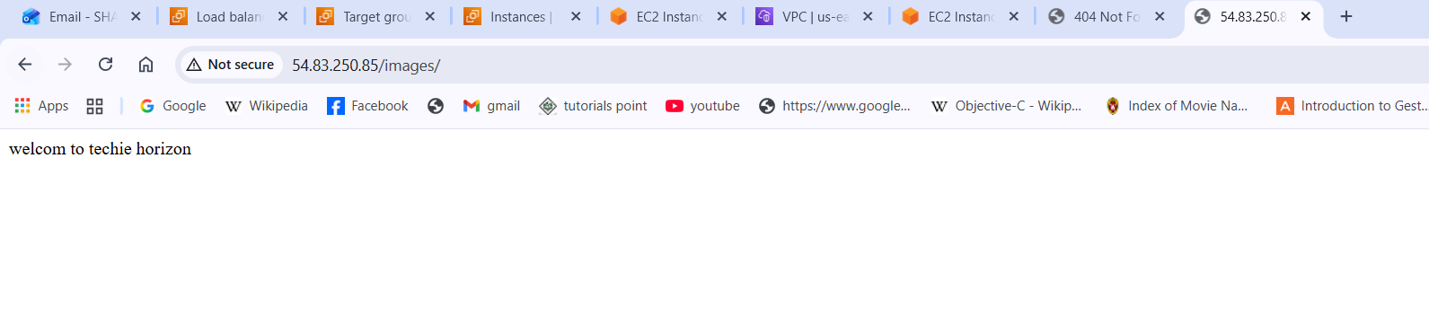
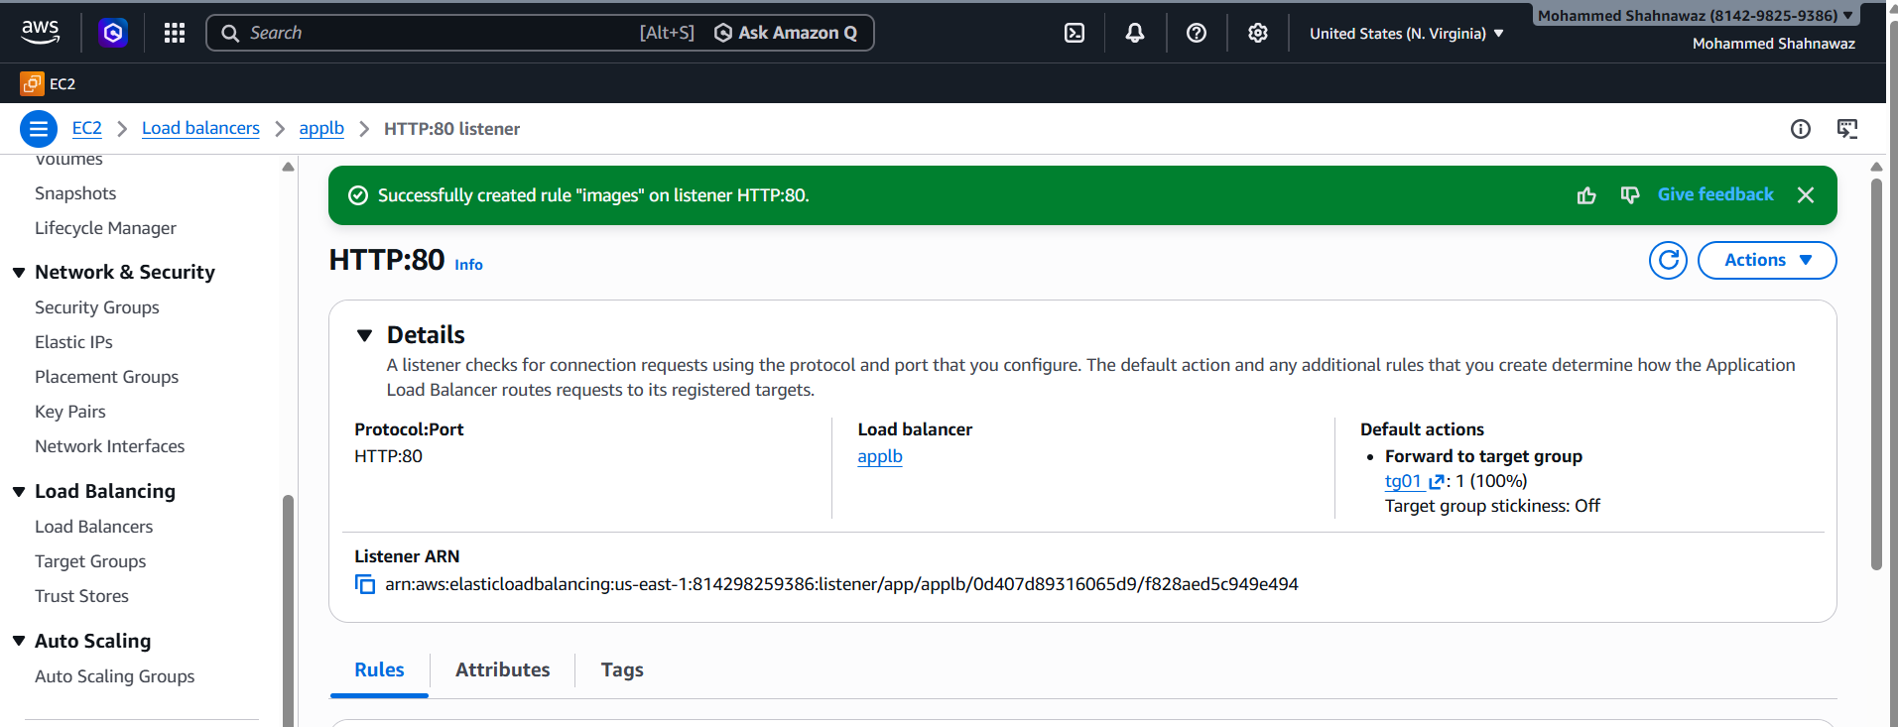
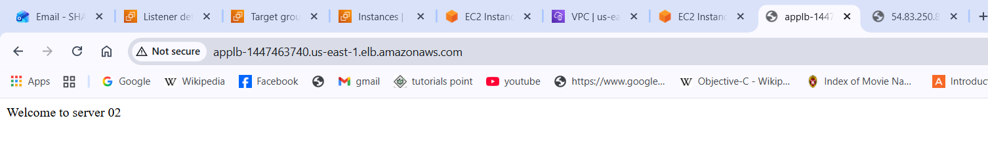
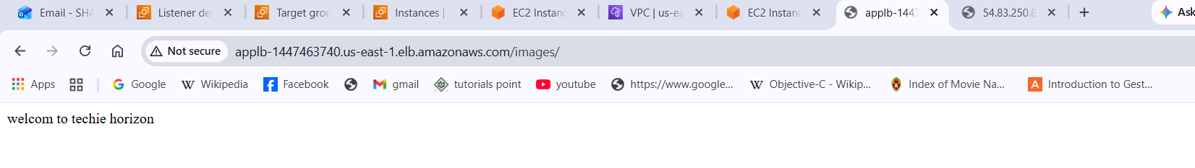

- Configure Network Load balancer.

Steps to Configure a Network Load Balancer
- Prerequisites
  - A VPC with at least two subnets in different Availability Zones.
  - Backend EC2 instances or IP targets ready to receive traffic.
  - Decide if you need IPv4 only or dual-stack (IPv4 + IPv6).
- Create the NLB
  - Go to EC2 → Load Balancers → Create Load Balancer → Network Load Balancer.
  - Name: Choose a unique name.
  - Scheme: Select Internet-facing (for public apps) or Internal (for private apps).
  - IP Address Type: IPv4 or dual-stack.
  - Listeners: Add TCP/UDP listeners (e.g., TCP port 80, TCP port 443, or custom ports).
- Configure Network Settings
  - Select the VPC.
  - Choose subnets in at least two Availability Zones.
  - Optionally assign Elastic IPs for static IP addresses.
- Assign Security Groups
  - Unlike ALB, NLB does not use security groups directly.
  - Ensure your target instances’ security groups allow inbound traffic from the NLB.
- Create Target Groups
  - Define a target group (EC2 instances, IP addresses, or Lambda functions).
  - Choose protocol (TCP, UDP, TLS).
  - Configure health checks (protocol, port, thresholds).
- Register Targets
  - Add EC2 instances or IPs to the target group.
  - Ensure instances are running and security groups allow traffic from the NLB.
- Configure Routing
  - Associate the listener with the target group.
  - Optionally configure TLS termination if using TLS listeners.
- Review and Create
  - Double-check all settings.
  - Click Create Load Balancer.
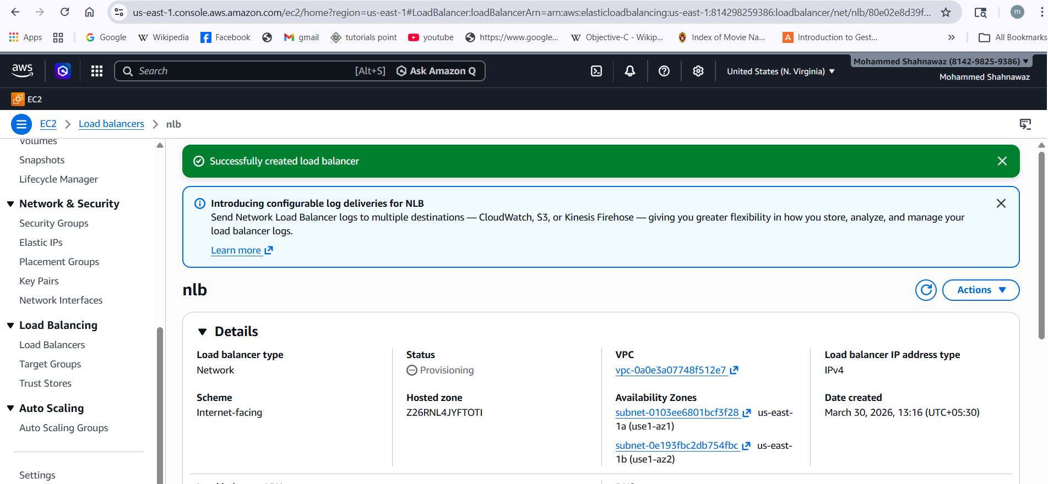
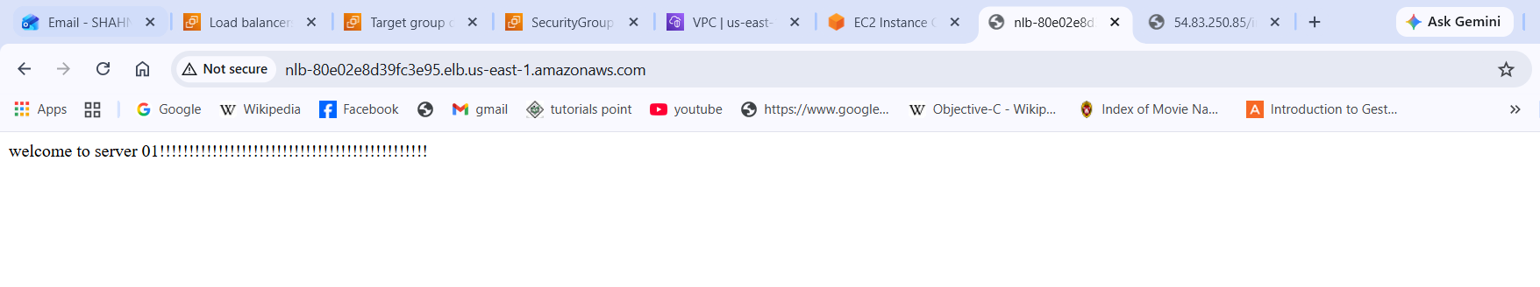
- Attach SSL for application load balancer.
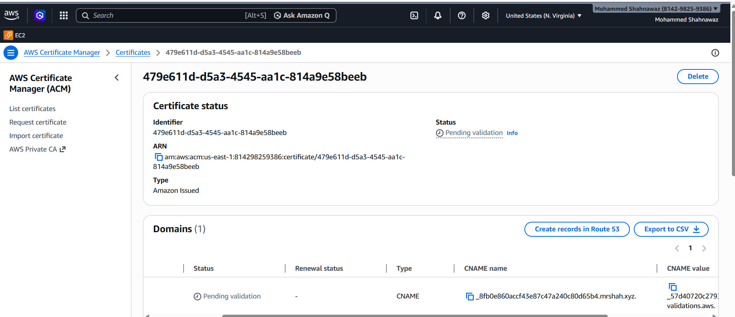
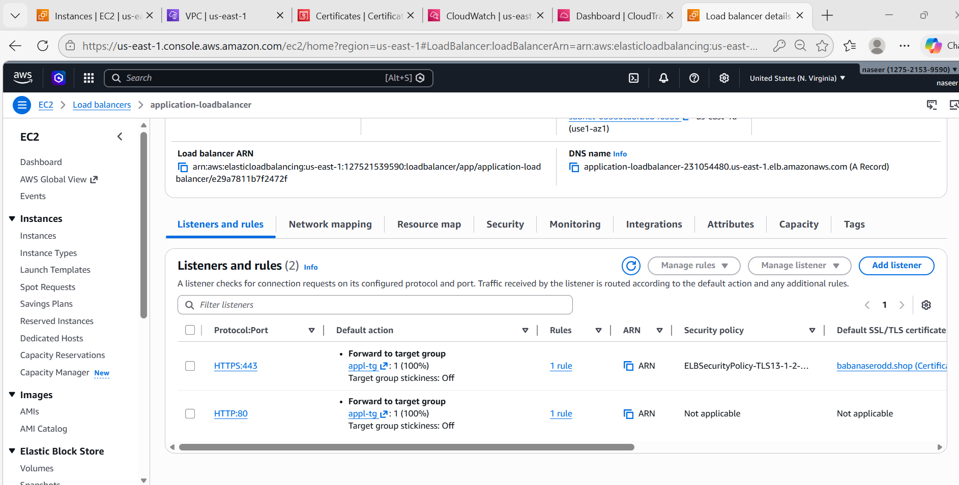
- Map Application load balancer to R53.
Steps:
Go to Route53
Create Hosted Zone.
Example: example.com and Create Record
Click Create Record
Type
A Record
Alias
Yes
Alias Target
Select
Application Load Balancer
Example
ALB-Web
Save.
Now domain works.
Example
https://example.com

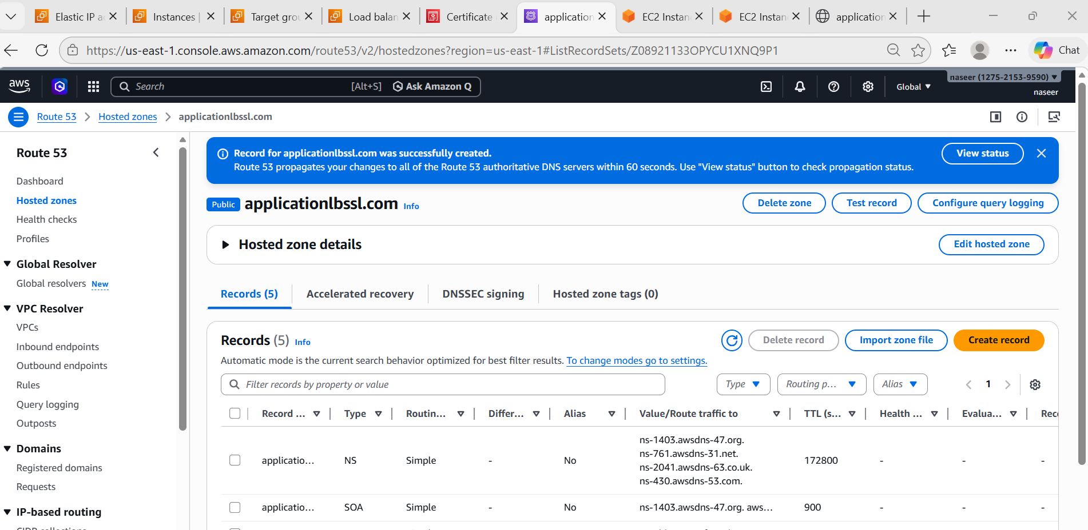
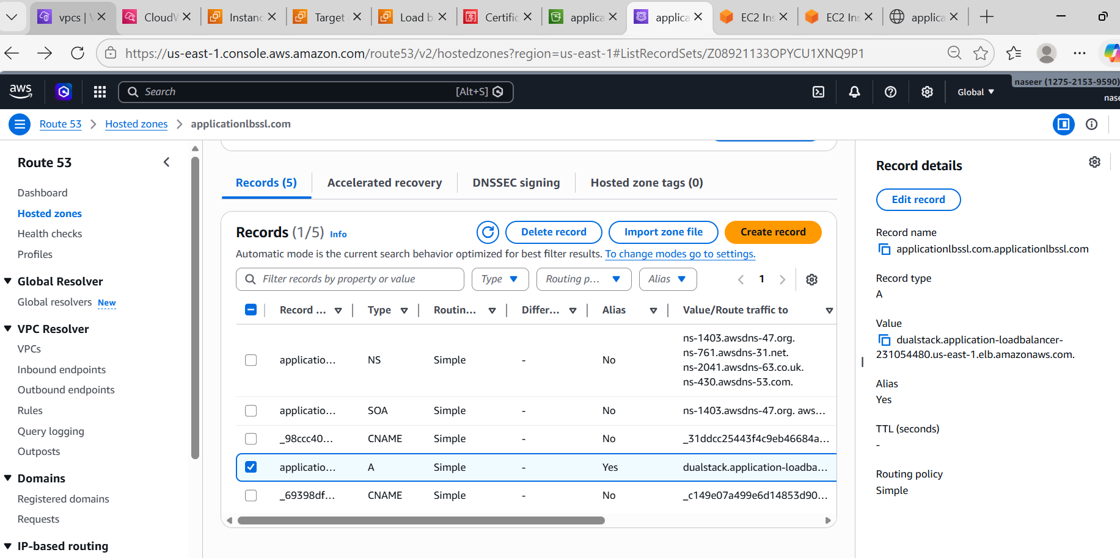

- Push the application load balancer logs to S3.
Steps:
- Create S3 Bucket
Go to S3 → Create Bucket
Name: applicationlg-bucket
Disable
Block Public Access
Create.
Enable Access Logs
Go to EC2 → Load Balancer → application-loadbalancer
Select
Attributes
Edit
Enable
Access Logs
Select bucket: applicationlg-bucket
Save.

{
"Version": "2012-10-17",
"Statement": [
{
"Sid": "AWSLoadBalancerLogsPolicy",
"Effect": "Allow",
"Principal": {
"Service": "logdelivery.elasticloadbalancing.amazonaws.com"
},
"Action": "s3:PutObject",
"Resource": "arn:aws:s3::: applicationlg-bucket /AWSLogs/*"
}
]
}

- Check Logs
Go to S3 → applicationlg-bucket
You will see
AWSLogs/
account-id/
elasticloadbalancing/
Logs stored successfully

